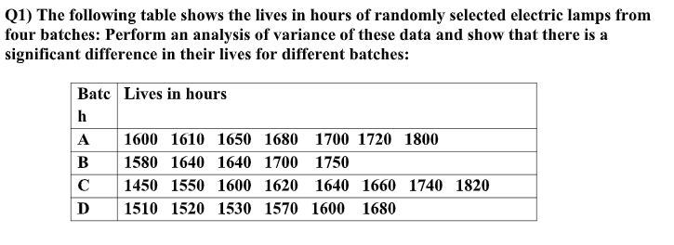
CODE :
data=read.csv(file.choose())

head(data)
LIVES=data$LIVES
BATCH=data$BATCH
res=aov(LIVES~BATCH)
summary(res)
#H0: There is no significant difference between mean life of lamps on batches
#H1: Atleast one of the mean life of lamp is different from other
OUPUT:
> head(data)
LIVES BATCH
1 1600 A
2 1610 A
3 1650 A
4 1680 A
5 1700 A
6 1720 A
> LIVES=data$LIVES
> BATCH=data$BATCH
> res=aov(LIVES~BATCH)
> summary(res)
Df Sum Sq Mean Sq F value Pr(>F)
BATCH 3 44391 14797 2.101 0.129
Residuals 22 154963 7044
> #H0: There is no significant difference between mean life of lamps on batches
> #H1: Atleast one of the mean life of lamp is different from other
> #pvalue=0.129 is greater than los (0.05), Accept H0
> #Hence we conclude that there is no significant difference between mean life of lamps on batches
> boxplot(LIVES~BATCH,col=c("red","blue","green","yellow"),main="BoxPlot")
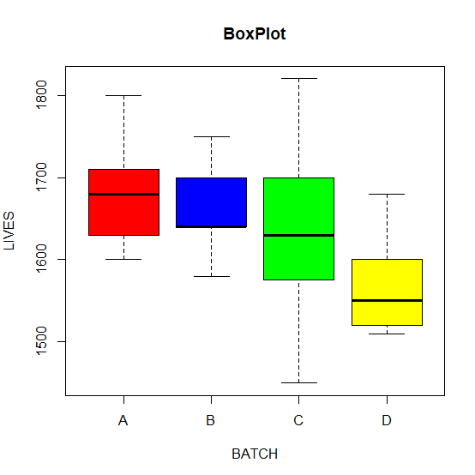
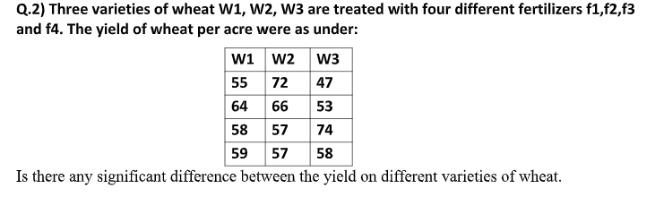
CODE:
data=read.csv(file.choose())

head(data)
Y=data$Y
W=data$W
res=aov(Y~W)
summary(res)
#H0: There is no significant difference between mean life of Y on W
#H1: Atleast one of the mean life of Y is different from other
#pvalue=0.672 is greater than los (0.05), Accept H0
boxplot(Y~W,col=c("red","blue","green","yellow"),main="BoxPlot")
OUTPUT:
> head(data)
Y W
1 55 W1
2 64 W1
3 58 W1
4 59 W1
5 72 W2
6 66 W2
> Y=data$Y
> W=data$W
> res=aov(Y~W)
> summary(res)
Df Sum Sq Mean Sq F value Pr(>F)
W 2 56 28.00 0.416 0.672
Residuals 9 606 67.33
> #H0: There is no significant difference between mean life of Y on W
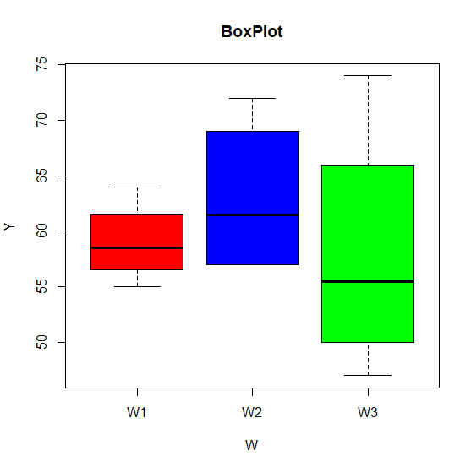
> #H1: Atleast one of the mean life of Y is different from other
> #pvalue=0.672 is greater than los (0.05), Accept H0
> boxplot(Y~W,col=c("red","blue","green","yellow"),main="BoxPlot")

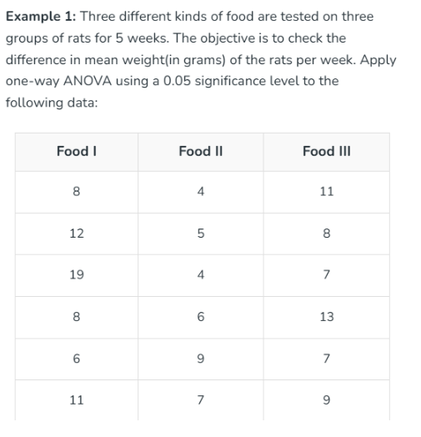
CODE :
data=read.csv(file.choose())

head(data)
WEIGHT=data$WEIGHT
FOOD=data$FOOD
res=aov(WEIGHT~FOOD)
summary(res)
#H0: There is no significant difference between mean life of WEIGHT on FOOD
#H1: Atleast one of the mean life of WEIGHT is different from other
#pvalue=0.0545 is greater than los (0.05), Accept H0
boxplot(WEIGHT~FOOD,col=c("red","blue","green","yellow"),main="BoxPlot")
OUTPUT:
> head(data)
WEIGHT FOOD
1 8 F1
2 12 F1
3 19 F1
4 8 F1
5 6 F1
6 11 F1
> WEIGHT=data$WEIGHT
> FOOD=data$FOOD
> res=aov(WEIGHT~FOOD)
> summary(res)
Df Sum Sq Mean Sq F value Pr(>F)
FOOD 2 73.44 36.72 3.554 0.0545 .
Residuals 15 155.00 10.33
---
Signif. codes: 0 ‘***’ 0.001 ‘**’ 0.01 ‘*’ 0.05 ‘.’ 0.1 ‘ ’ 1
> #H0: There is no significant difference between mean life of WEIGHT on FOOD
> #H1: Atleast one of the mean life of Y is different from other
> #pvalue=0.0545 is greater than los (0.05), Accept H0
> boxplot(WEIGHT~FOOD,col=c("red","blue","green","yellow"),main="BoxPlot")
